About

This tool is developed for wildlife detection. Currently, the tool is supported by Python3, Pytorch and Detectron2.

**Installation**

To use the tool, please install the Detectron2 following the [installation instructions](https://detectron2.readthedocs.io/tutorials/install.html).

You also need to install the following packages:

* opencv: pip install opencv
* ensemble-boxes: pip install ensemble-boxes
* scikit-imag: pip install scikit-imag
* imanticse: pip install imantics
* Pillow: pip install Pillow

**Usage**

When using this tool run ‘python main.py -h’ or ‘python main.py --help’ to get the help information.

Currently the following parameters can be used:

--ImgPath The path of the image file.

--DirPath The path of the image dir.

--Classification_Usage If classification model will be used to help detection.

--WBF_Usage If Weighted-Boxes-Fusion will be used to help detection.

--Output_Dir Setup the path of output results you want to save.

--Draw_Detection If generating images with detected animals.

You must offer a valid image path or the path of a folder with images, currently we only support ‘.jpg’ and ‘.JPG’ files.

Example commands:

Basic running:

python main.py --DirPath /Volumes/LIN/ANIMAL_DETECTION/DEMO_DATA

Running with draw detection output:

python main.py --DirPath /Volumes/LIN/ANIMAL_DETECTION/DEMO_DATA --Draw_Detection True

Running with classification and WBF:

python main.py --DirPath /Volumes/LIN/ANIMAL_DETECTION/DEMO_DATA --Draw_Detection True --Classification_Usage True --WBF_Usage True

Running with specific output folder:

python main.py --DirPath /Volumes/LIN/ANIMAL_DETECTION/DEMO_DATA --Output_Dir /Volumes/LIN/ANIMAL_DETECTION/DEMO_OUTPUT/OUTPUT_TEST

**Output**

**1. Normal output json file**

The default output file is ‘detection.json’ file:

{

"Armadillo7": [

{

"id": 1,

"bbox": [

[

0.2148,

0.6778,

0.4016,

0.7958

]

],

"class": "Armadillo",

"conf": 0.9924

}

],

"Armadillo2": [

{

"id": 1,

"bbox": [

[

0.2422,

0.6505,

0.4714,

0.9097

]

],

"class": "Armadillo",

"conf": 0.9932

}

]

}

**2. CSV file with Detection result:**

The program will also generate a csv file called ‘detection.csv’ with detection result:

**3. Image with Detection result:**

If ‘--Draw_Detection’ is set to ‘True’, there will be a folder called ‘IMG_WITH_BBOX’ with the images with detected bounding boxes on it.

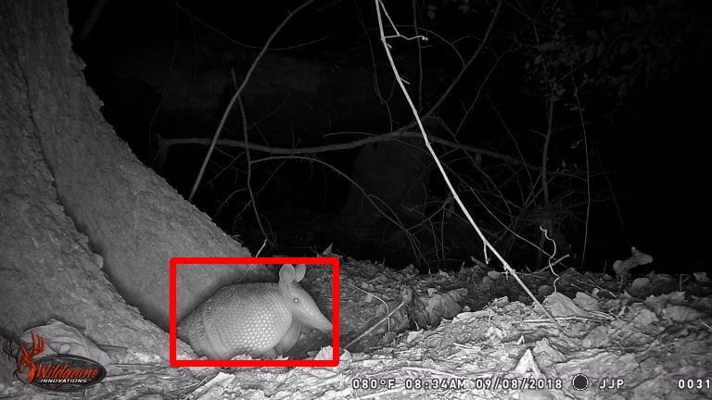

**4. Intermedia result (cropped images) for classification model:**

If ‘--Classification_Usage is set to ‘True’, there will be a folder called ‘CROP_IMG’ with the cropped images detected by the detection model.

Example Cropped Image:

